File Management:
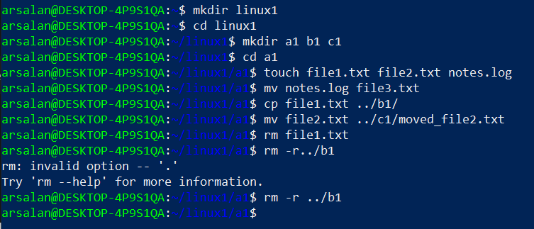
mkdir linux1: Creates a new folder named linux1 inside your home directory.
cd linux1: Moves you inside the linux1 folder.
mkdir a1 b1 c1: Creates three folders inside linux1(a1,b1,c1).
cd a1: You move inside the a1 folder.
touch file1.txt file2.txt notes.log: Creates three empty files inside a1.
mv notes.log file3.txt: This command renames:
- notes.log → file3.txt
You are still inside a1, so the rename happened inside the same folder.
cp file1.txt ../b1/: Copies file1.txt from a1 to the b1 folder (which is one level up).
mv file2.txt ../c1/moved_file2.txt: Moves and renames file2:
- Moves file2.txt from a1 → c1
- Renames it to moved_file2.txt
rm file1.txt: Removes (deletes) the file file1.txt from a1.
rm -r ../b1: Deletes the entire b1 folder (recursively) and everything inside it.
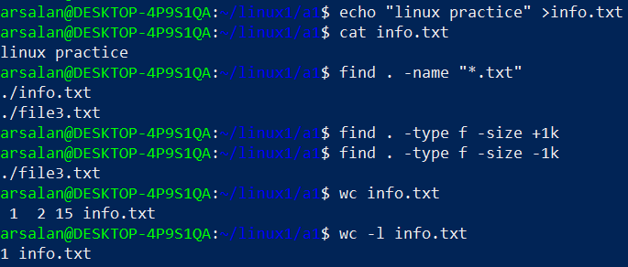
echo “linux practice” >info.txt: Creates a file named info.txt (or overwrites it if it exists) and Writes the text: linux practice.
cat info.txt: Prints the content of info.txt.
find . -name “*.txt”: Finds all .txt files in the current folder (.) and subfolders.
find . -type f -size -1k: Finds files smaller than 1 KB.
Wc info.txt: Counts lines, words, bytes in info.txt.
wc -l info.txt: Counts only lines.

Permission Management: 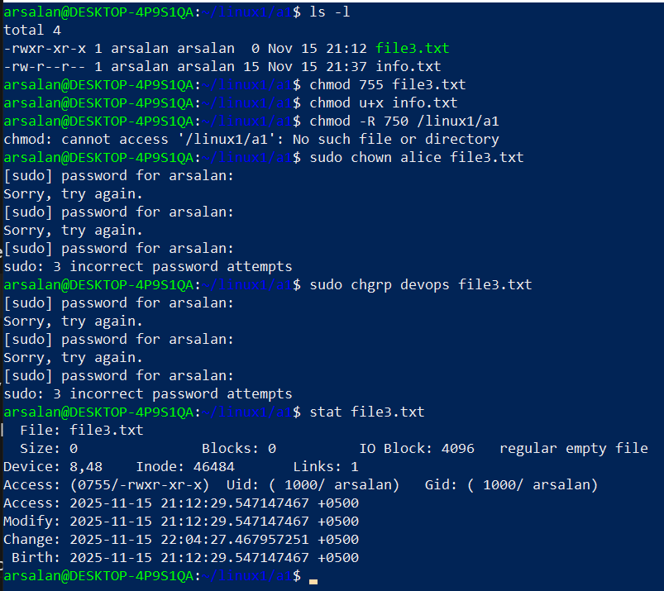
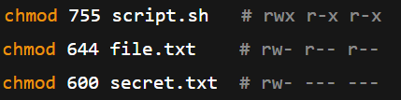
ls -l: checks all directories permissions.
chmod 755 file3.txt:
• Sets permissions to rwxr-xr-x
• Owner: read/write/execute
• Group: read/execute
• Others: read/execute
Chown for owner changing , chgrp for group changing.
stat gives detailed file info.
sudo requires your user password, and 3 wrong attempts will abort.
Networking Commands:
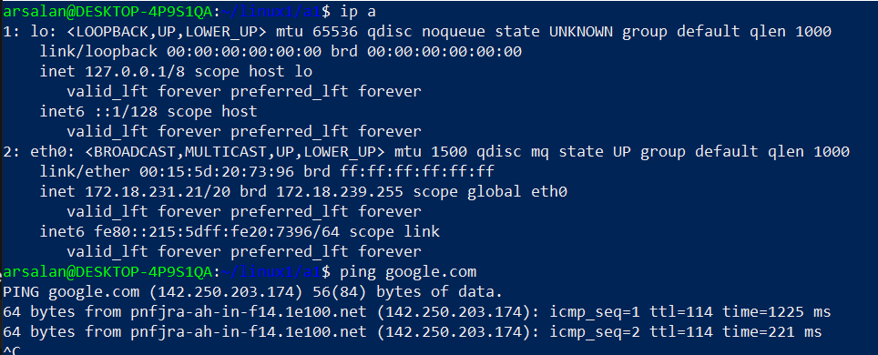
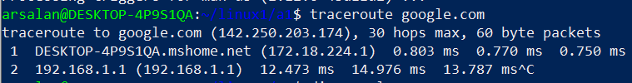
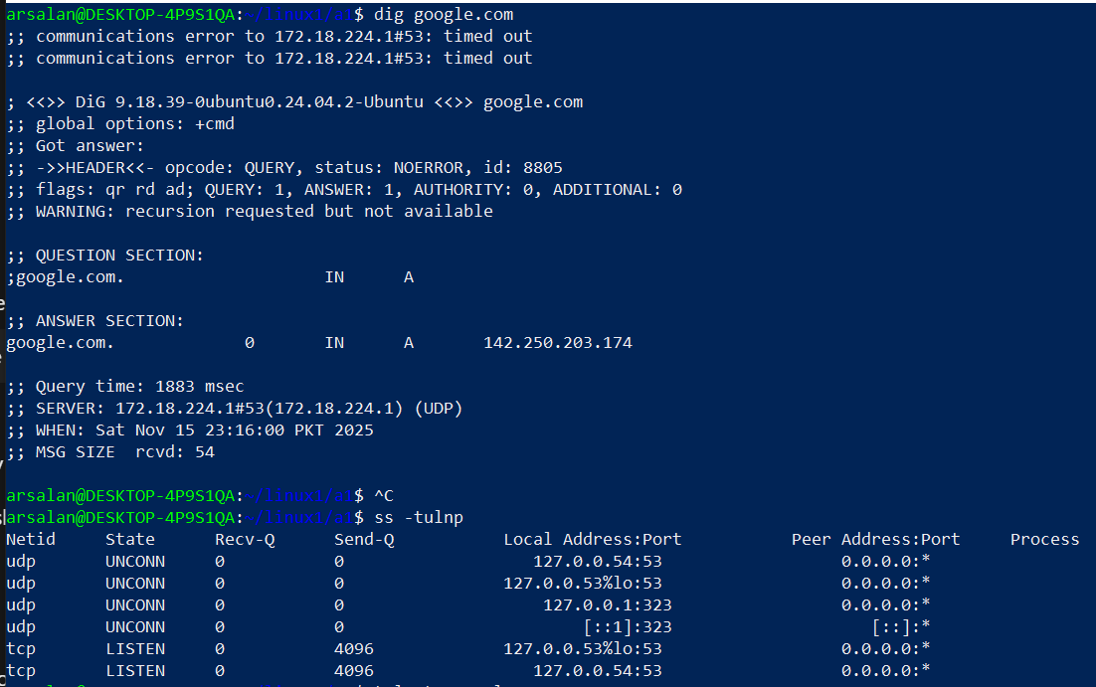
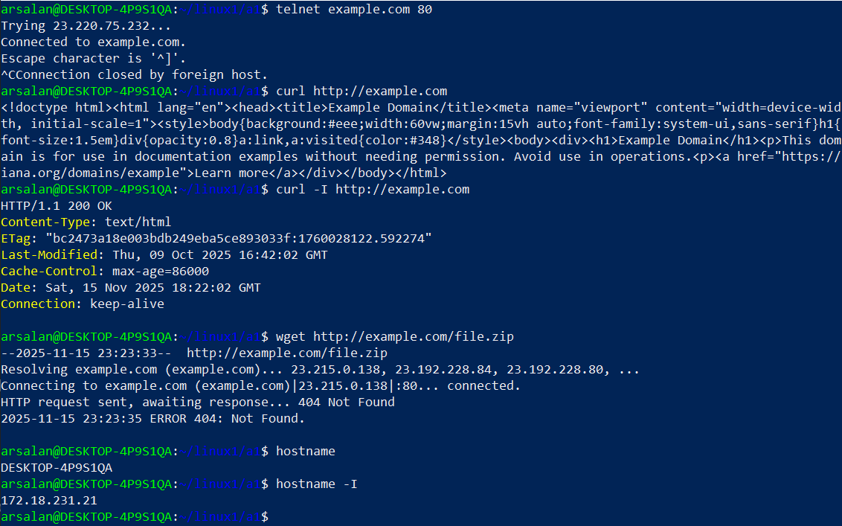
Ip a : Shows the IP addresses of system.
Ping: Test if a host is reachable.
traceroute: Shows the path packets take to reach a host.
dig: Check domain name resolution.
ss -tulnp: show active connections and listening ports.
telnet: Check if a port is open on a server.
curl, curl -I, wget : Check HTTP responses or download files.
hostname, hostname -I: Check hostname and domain.

Install and Configure git:

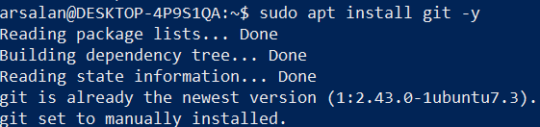
Configuring git user Sets name and email globally for commits.
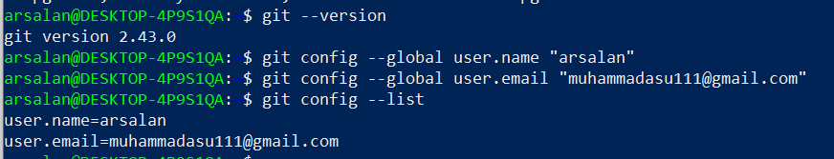
Create peoject folder: Creates and enters a folder for your project.
Echo: Creates a file readme.txt with content hello git.
Initalize git repository: Creates a new Git repository in the folder (default branch: master).
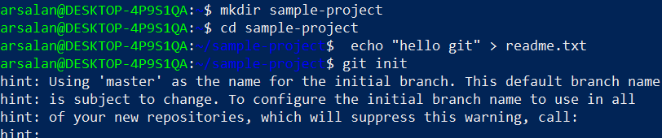
Stage and commit changes: Adds all files to staging and makes the first commit (git add)(git commit -m “initial commit”).
Add remote repository: Links local repo to GitHub (git remote add, -v).
Rename branch: Changes default branch from master → main(git branch -M main).
Push changes: Pushes local commits to GitHub main branch(git push -u origin main).

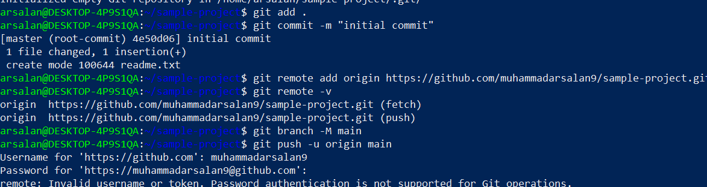
Check git status: Shows the working tree is clean; everything is pushed.
View commit history: Shows commits in short form (one line per commit).
Verify remote: Confirms the GitHub URL for fetch/push( git remote -v).

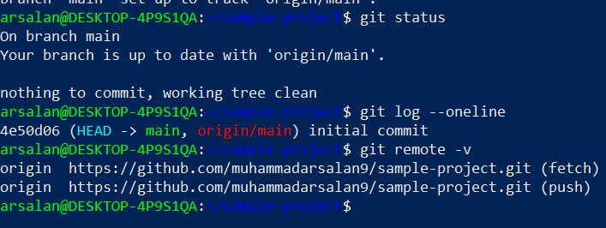
Clone repository: Downloads the GitHub repo to your home directory.

